Playwright
Note for Windows PowerShell Users.
In the next chapter, while executing npm init playwright, you might see an error in powershell.

Here's how you can fix it:
- Here are the steps to fix the issue persistently:

- 1. **Open PowerShell as Administrator**:
- * Search for "PowerShell" in the Start menu.
- * Right-click it.
- * Select **Run as Administrator**.

- 2. **Check Current Execution Policy**:
- * Run this command in PowerShell:
- `Get-ExecutionPolicy -List`
- * This shows policies for different scopes.

- 3. **Set Persistent Execution Policy**:
- * To allow scripts for your user account persistently:
- `Set-ExecutionPolicy -Scope CurrentUser -ExecutionPolicy Bypass`
- * This setting applies only to your user account.
- * It remains active after you restart your computer.
- * Answer 'Y' (Yes) if prompted to confirm the change.

- * Alternatively, to allow scripts for all users persistently (requires administrator privileges):
- `Set-ExecutionPolicy -Scope LocalMachine -ExecutionPolicy Bypass`
- * This setting applies to all users on the computer.
- * It remains active after restarts.
- * Answer 'Y' (Yes) if prompted.
- * Choose the scope (`CurrentUser` or `LocalMachine`) that best fits your needs. `CurrentUser` is often sufficient and safer.

- 4. **Run Your Command Again**:
- * Retry your `npm init playwright` command.
- * It should run without the execution policy error.

- **Additional Notes**:

- * Using `Bypass` lets any script run. Understand the security risk before proceeding.
- * If problems continue, consider reinstalling Node.js. Get the latest version from the Node.js website.
npm Error in PowerShell (for Windows Users)

Fixing the "running scripts is disabled on this system" npm Error in PowerShell
If you encountered a the below error that stops your commands from running. It often looks something like this:
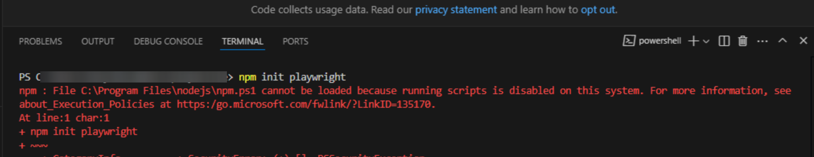

This error isn't an issue with npm or Node.js itself.
It's a security feature of Windows PowerShell called the Execution Policy. By default, PowerShell is configured to prevent the execution of scripts to protect you from potentially malicious code. Since the npm command on Windows can be a PowerShell script (npm.ps1), the default policy blocks it.

The Solution: Changing the PowerShell Execution Policy
Follow these steps to safely allow scripts to run for your user account, which will resolve the npm error.
- Open PowerShell as an Administrator
You need administrative privileges to change execution policies.
  - Press the Windows key, then type "PowerShell".
  - Right-click on "Windows PowerShell" in the search results.
  - Select "Run as Administrator" from the context menu.
  - Click "Yes" on the User Account Control (UAC) prompt.

- Check Your Current Execution Policy
Before making changes, it's good to see how your system is currently configured. Run the following command in the administrative PowerShell window:
  - Get-ExecutionPolicy -List
This command will display the execution policies set for all scopes (like LocalMachine, CurrentUser, etc.). You'll likely see that one or more scopes are set to Restricted or AllSigned.
- Set a New Execution Policy for Your User
The safest way to fix this issue is to change the policy only for your user account, leaving the system-wide policy intact. The Bypass policy allows any script to run without warnings or prompts.
Run this command to set the policy for the current user:
  - Set-ExecutionPolicy -Scope CurrentUser -ExecutionPolicy Bypass
  - -Scope CurrentUser: This ensures the change only applies to your user account and doesn't require administrator rights for future PowerShell sessions.
  - -ExecutionPolicy Bypass: This allows all scripts to run.
PowerShell may ask for confirmation. Type Y and press Enter to confirm the change.
- Verify and Rerun Your Command
You can now close the administrator PowerShell window and open a regular one (like the one in your code editor). Try running your command again:
  - npm init playwright@latest
The error should now be gone, and your command should execute as expected!

Important Considerations
- Security First: The Bypass policy removes a layer of security. Only run scripts from sources you trust. For most development work, this risk is minimal, but it's important to be aware of it.
- Alternative Scopes: While CurrentUser is recommended, you could apply this to the whole machine with Set-ExecutionPolicy -Scope LocalMachine -ExecutionPolicy Bypass. This is generally not necessary and less secure.
